Call for ideas for ICO Inclusion and Diversity Screening Days


The Independent Cinema Office (ICO) are looking for people who have ideas for an event called: Inclusion and Diversity Screening Days.

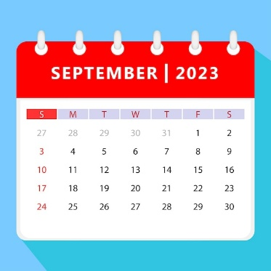 This event will be in September.

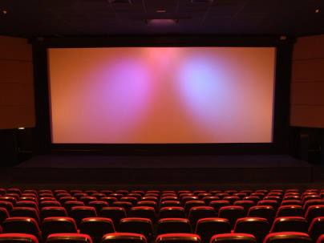
This is for people who work in film exhibition. This can include people who work for cinemas, film festivals or film societies.


For the event, we want ideas for either film screenings,

or…


practical sessions.


You do not need to work in film exhibition to give us your ideas.

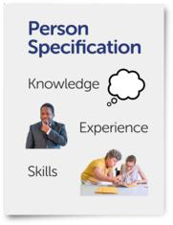
If you have practical experience of working with diverse audiences or a diverse workforce, we want to hear from you.

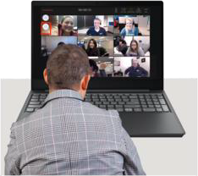
The event will be both in a cinema and online, and you can choose to run a session from either.


At the event, we will look at Inclusion and Diversity in film exhibition, and how people from many different backgrounds can feel able to take part.


We think that, at the moment, the main things we need to look at are:

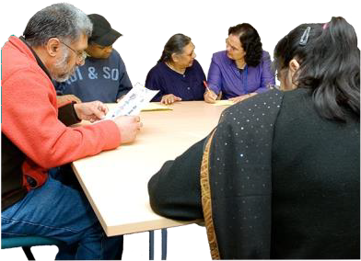
Race and ethnic diversity,


Disability,

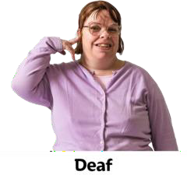
D/deaf,

Or…


Neurodiversity, meaning people with different brain types. This can include learning disability or Specific Learning Difficulties (SpLDs)



Sexuality.


Trans and gender non-conforming people,

And…


Class and access to equal opportunity


There will be preview screenings. This means films which are shown before the public get to see them.


The films are ones that not everyone will have heard about or have cost huge amounts of money to make.

They will be:

independent films, made by smaller
companies,

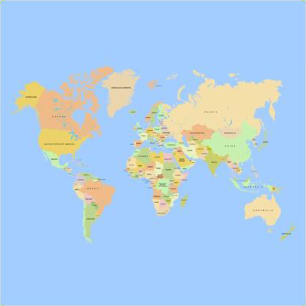
made in countries around the world,

Or…

arthouse: experimental and art films.


The preview screenings mean that exhibitors can watch films they can think about showing at their cinema, festival or film club.


The films should mean more people from different backgrounds will want to come to their screenings.


If you have shown a film recently, which you think reached diverse audiences, you may want to come to this event to talk about how you did this.

You can also talk about the film itself.

The event could help you find more people who want to help you put on showings of the film.


As well as the film screenings, there will be sessions to help film exhibitors’ reach new and diverse audiences.

The sessions should help to keep diverse

audiences interested in their screenings.

The sessions can also be about making a workplace more welcoming for people from all backgrounds.


We would like session ideas about inclusion and diversity that may be important to you, or which you think are not talked about enough in film exhibition.


They should focus on a clear topic,

and…


Help exhibitors use the ideas to make their screenings or organisations better.


A session can be done in different
ways.

For example, you could think about doing:


A panel discussion with a group of people who know a lot about the topic you have chosen.

A case study where you can tell us about film screenings or events you or someone you know has run.


A discussion about an important issue in exhibition,

or…

A workshop where you can give practical ideas, which exhibitors can use to improve their services for more people.

Your session topic could be on a range of subjects,

for example:


Marketing.

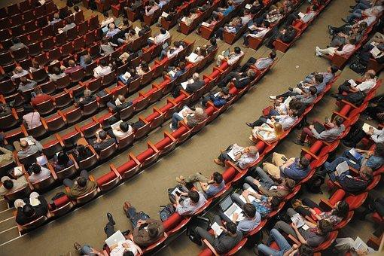
Reaching new audiences


Reaching online audiences for events in person


Finding films by diverse filmmakers that are important to the history of cinema


Making diverse audiences in rural settings feel included


Making changes to the way a cinema works to include diverse audiences or staff.


If we want to use your idea, we can pay a fee of £500 for organising the session.

You will also get a free pass to attend the event.


We can also give you some money to pay people who speak at the event.


Our team at the ICO can work with you to organise and develop a session if you’d like.


We can also try to find other people who might like to work with you on the session as a partner.


If you, anyone working on the session, or anyone who may come to the session have access needs, we can help with this.


You should let us know your ideas by:
Wednesday 23rd July at 5PM


Email your ideas to Duncan Carson, at duncan.carson@independentcinemaoffi ce.org.uk

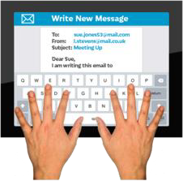
Your session idea should be typed, on no more than 1 page, and tell us:


- The title of your session

- What the session would be about,

and…

- how it would work


Also tell us about…

Any people you would like to speak on your
event, if needed.


The ICO team and our Screening Days Advisory Group will look at all of the ideas.



We hope to let you know if we want to use your idea by Wednesday 6th August.


If your idea is chosen you will have about
6 weeks to plan your session.


We look forward to hearing your ideas!

