Picturehouse Entertainment
Marketing and Distribution Assistant

12 month fixed-term position at Orange Street Head Office
July 2022 - July 2023

Picturehouse is a leading UK film company incorporating cinema exhibition and film distribution. Find out more at Picturehouses.com/about-us

Vacancy
The key to this role is providing support to the Picturehouse Entertainment team across all strands of the company, supporting both Theatrical and Home Entertainment releases. You will be an integral part of a small, dedicated team working to release outstanding films from around the world and connect them with wide and under-served audiences in a unique and visionary way.

Who we are
- The award-winning film distribution arm of Picturehouse. Our releases serve audiences across the UK in all cinemas nationwide.
- We believe that great cinema has the power to change lives but should always have entertainment as an essence. We work to ensure great film, that might otherwise go undiscovered, finds its big-screen audience.
- Since 2010, we’ve worked across an extensive catalogue of films. Since cinemas reopened their doors in May 2021, we have released 12 films exclusively in cinemas, including Sean Durkin's THE NEST starring Jude Law and Carrie Coon, Phyllida Lloyd’s HERSELF, Reggie Yates’ directorial debut PIRATES, Joanna Hogg’s critically acclaimed THE SOUVENIR PART II, Audrey Diwan’s BAFTA-nominated HAPPENING, and Gaspar Noé’s VORTEX.

Who you are
- Passionate about arthouse and independent film with an interest in the themes and content of each release.
- A confident communicator, proficient in administration with great attention to detail. Highly motivated, thriving in fast-paced environments.
- A talented copywriter, who is confident in writing everything from short, snappy tweets to longer-form blog content.
- Social media savvy, with an understanding of how to best utilise platforms and share content.
- A creative thinker who loves to think outside the box and come up with innovative and creative solutions to marketing and engaging audiences.
- A team player who enjoys working collaboratively and is keen to develop and expand their understanding of the life-cycle of a film, working from pre-release, through to theatrical and home entertainment post-release.

Responsibilities:
- To provide support across Picturehouse Entertainment’s marketing, sales, publicity, technical and event management teams.
- To provide support where needed for the Picturehouse Cinemas marketing team.
- To support grassroots marketing and outreach for all upcoming cinema and home entertainment releases, including securing competitions and support from partners and ensuring they have all the materials necessary to promote the release.
- Input into broader marketing plans and activities, attending film screenings and brainstorming sessions for upcoming releases.
- Liaise with exhibitor marketing teams to deliver marketing materials and assets to venues and ensure they’re correctly displayed and uploaded.
- Assist with the creation and distribution of content for social media.
- Check and update film websites and digital platforms including the main ticketing websites for each film, as well as social media channels.
- Provide on the ground support for events such as premieres, festivals and special event screenings such as Q&As.
- Assist marketing and publicity teams with managing RSVPs and guest lists for a range of screenings and events.
- Supporting the Technical & Production department in relation to some core tasks over the course of each release, including dispatching KDMs.
- Assisting with the production of campaign reports and presentations for internal use.
- Performing general administrative duties where required including keeping minutes for meetings, helping to ensure that internal worksheets and documents are kept up to date, and raising PO’s.
- Provide other support within Picturehouse Entertainment as reasonably required.

Office:
This is a full-time role working Monday to Friday with occasional evening and weekend work required. The role will be based four days a week in Picturehouse Head Office and up to one day a week from home.

Pay:
We offer an annual salary of £22,000 for this role.

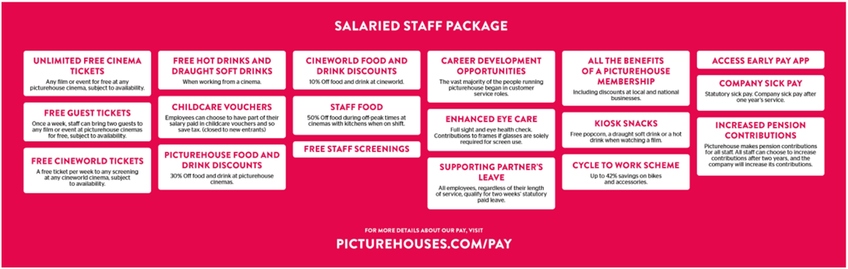

Application:
To apply for this role, please email a CV and cover letter telling us why you’re the perfect fit for the role to mo.abdelhalim@cineworld.co.uk by 19/06/2022

