Picturehouse Cinemas Limited
Café Supervisor, Picturehouse East Dulwich July 2021

We are Lordship Lane's thriving community hub with three screens and bright café-bar and garden terrace.
Completed in 1882, our delightful building was originally shared between St Anthony's Church and St Anthony's School. From 1964, the building was then converted into a community hall, but over time its use diminished. Picturehouse took over the site in 2015 to lovingly restore the building and re-expose its architectural integrity.
Picturehouse Cinemas (www.picturehouses.co.uk) who operate 26 cinemas across the UK and are a stand-alone division of Cineworld PLC. https://www.picturehouses.com/cinema/east-dulwich
Vacancy
For your application to be successful, you will have relevant experience working in a similar role in a professional food and beverage operation. You will also have a track record of leading a team to deliver food and beverage for a wide spectrum of propositions; from casual café dining to premieres and events.

You will be experienced in managing a team, and should be comfortable working to tight budgets and targets as well as stock control and ordering processes.

As our Café Supervisor, the majority of your time will be spent customer facing, the remainder delivering and managing the F&B proposition, and as such, you must be an effective trainer and delegator to ensure standards are met at all times across front and back of house.

If you’re ready for a new challenge, and have a flair for leadership in the provision of delicious, contemporary food and drink offer for a diverse customer base, then we’d love to hear from you.

Please note there is a requirement to work 40 hours per week over any of the seven days with regular work at evenings and weekends.

We offer a salary of £10.16 paid hourly, plus bonus opportunities.

Office
The Café Supervisor is based at East Dulwich Picturehouse & Cafe, 116a Lordship Lane SE22 8HD

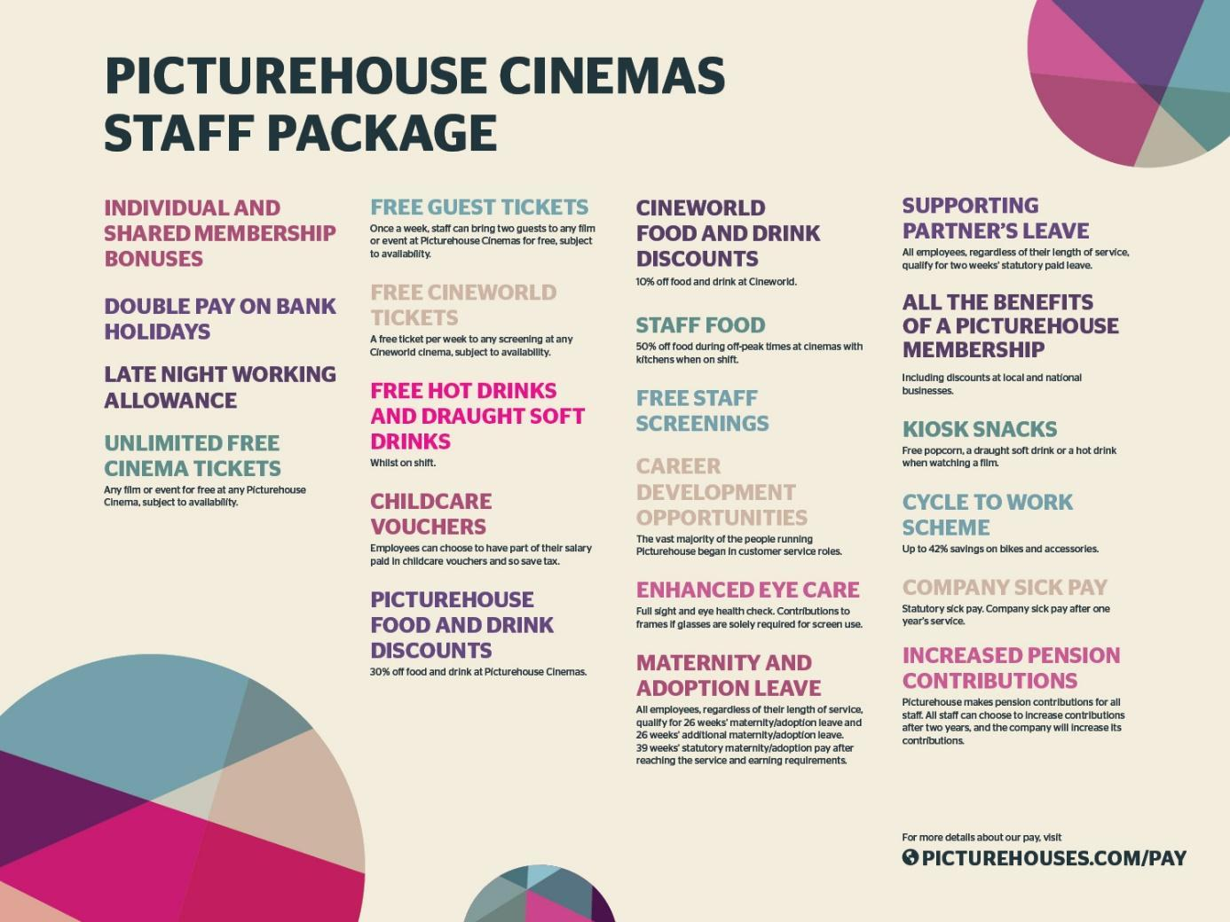

Application
To apply for this position please send your CV and covering letter to matthew.c@picturehouses.co.uk with “Cafe Supervisor, East Dulwich Picturehouse” in the subject line by Friday the 29th of April 2022.

Job Description: Café Supervisor

Job Purpose

To run the daily operations of the East Dulwich Picturehouse café-bar, maximising sales of food and drink throughout the day and offering the best possible customer service at all times whilst effectively managing team performance and budgets.

Main Duties

Your duties include:
- Taking full responsibility for the effective running of the café-bar.
- Building a reliable customer base that is independent to the regular cinema trade. Building the business and income levels through local community groups and promotion of events and activities.
- Assist the GM with the hiring of new staff, staff appraisals and dismissals (following company procedures and pay structures).
- Assist the GM with setting the rota for all areas of the café bar taking into account the projected trade in the cinema as well as the café itself ensuring budgets are adhered to.
- Maintaining the highest possible customer service levels in the bars at all times.
- Ensuring food hygiene standards are adhered to at all times, maintaining allergen data sheets, HACCP and training best practice to staff.
- Continually training staff with relevant F&B product knowledge and techniques to be able to sell the full range of products effectively and quickly.
- Liaising effectively with the head office F&B team
- Liaising with the entire café team, cinema General Manager and other cinema managers to ensure that the café-bar is closely integrated with the overall business of the venue – including being familiar with expected busy times and quiet times so that staffing can be organised accordingly. Conduct pre-shift briefings on each shift.
- Ensuring that the Food and Beverages offer is fully and attractively promoted using the communication toolkit (menu boards, table menus etc) available to you. Ensure food and drink is effectively and attractively merchandised while minimising stock wastage.
- Training all staff on the consistent delivery of all food and drink items. Identify training needs of the team and where external training is required, communicating training needs to the F&B Operations team.
- Taking responsibility for the changing ambience of the café and bar as it moves from a daytime proposition to an evening one; generally ensuring that the offer is appropriate for the time of day and the type of business/customer.
- Ensuring daily and weekly cleaning procedures are in place and undertaken effectively; taking responsibility for health and safety in the café and bar.
- Managing stock levels, including placing orders for all F&B outlets, organising all stocking and stock taking and ensuring that stock is not wasted through being out of date or bad storage. Ordering non-consumables for the café-bar (cleaning fluid, glasses etc.).
- Ensure all deliveries are receipted and processed following company procedures
- Maintaining the stores in a clean and tidy state at all times, including maintaining up to date store room planograms and ensuring that all stock is in date.
- Undertaking any other duties which may be reasonably requested of you by the management team for the effective functioning of the restaurant, bar and cinema.

Note: This job description reflects the present requirements of the post. As duties and responsibilities change and develop the job description will be reviewed and is therefore subject to amendment.

