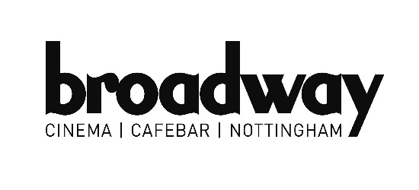
APPLICATION FORM

Please complete this form legibly and return it by email or post on or before the deadline date advertised. Late applications will not be accepted. Only information provided on this application form will be considered. All information given will be treated with the strictest confidence. Continuation sheets may be added if necessary.

POSITION APPLIED FOR:
PROJECT MANAGER, MAJOR PROGRAMMES, Film Hub Midlands

1. Personal Details

Mr / Ms / Miss | Surname: | First Name(s):
Address:

Telephone No: Home: Work: Ext.
Mobile: E-mail

2. Present / Most Recent Employer
Name and Address:

Nature of Business:

Job Title & Summary of key responsibilities and duties:

Present Grade/Salary  Date of Appointment: | Other Benefits:  Notice Required:
3. Education – Training - Qualifications
.
Secondary School/  College/University  (most recent first) | From | To | Qualifications gained (state level) | Grade | Date
4. Previous Employment and Work Experience
Please detail all previous work, whether paid or voluntary, which you have undertaken. Highlight (*) the two most relevant and note what you achieved. Continue on another sheet, if necessary. (Most recent first)
From – To  month/year |  | Employer | Job Title & Responsibilities (*) | Reasons for leaving

5. Specific information in support of your application
Please explain why you are applying for the job and how your skills, experience and achievements are relevant to post with specific reference to the person specification and the job description where provided. Continue on another sheet, if necessary. You may submit your answers via recorded video and must add unlisted video links in this space.

6. Additional Information
Please give details of any additional information, not covered elsewhere, which will give strength to your application. Continue on a separate sheet if needed.

9. References
Please give the names and addresses of two referees who know you and how you work. One of these should be your present employer.
REFEREE 1
Name ____________________________________________________________________________

Address ____________________________________________________________________________
___________________________________________________________________________________
Telephone ______________________ Email _________________________________________
How you know the referee ____________________________________________________________
REFEREE 2
Name ____________________________________________________________________________

Address ____________________________________________________________________________
___________________________________________________________________________________
Telephone ______________________ Email _________________________________________
How you know the referee ____________________________________________________________
May we request a reference before making an offer of employment?

Referee 1 Yes / No Referee 2 Yes / No

9. General
Please state where you heard about this vacancy:

Declaration
All the information given in this application is correct as far as I know. I understand that it will be treated as part of any subsequent contract of employment.

Signature: Date:

Please return your application either by post or email to:

recruitment@broadway.org.uk

or

Recruitment
Broadway
14-17 Broad Street
Nottingham
NG1 3AL

YOUR PERSONAL DATA :

The General Data Protection Regulation (GDPR) regulates the way that we process the data of job applicants and we need your consent to do this. With this form, we are asking you to provide your consent for us to process your data during the selection process and to keep your data for a period of 6 months once the selection process has been concluded. Your data will be retained in order to enable us to respond to any enquiries about this recruitment selection process and also so that we may measure your suitability for any future vacancies that arise during the following 6 month period.

You are entirely in control of your decision to give consent to our use of your data as requested in this form. You do not need to give consent. There will be no repercussions if you choose to withhold consent and your data will be deleted/destroyed.

Declaration
- I am giving my consent to Broadway to use my data as indicated above
- I understand that I am not required to give consent to Broadway’s use of my data in the ways set out in this form. Where I have done so, I have done so of my own free will
- I understand the ways in which the Company wishes to use my data as set out above
- I understand there will be no repercussions if I refuse to give consent in this form
- I know that I can withdraw my consent at any time.

Signed: __________________________________________________

Dated: __________________________________________________

Withdrawal of Consent :
Signature | Dated | Actioned by | Dated

